**The Ultimate BMW E46 Suspension Refresh Guide with Complete Parts List**

BMW E46 Suspension Guide

*by E46Mango*

[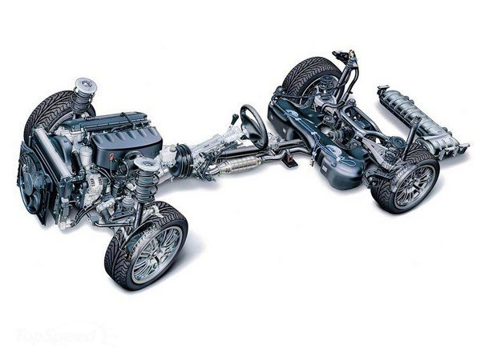](https://3.bp.blogspot.com/-fLVn2J3G-os/V_R9JGlhs1I/AAAAAAAAAPg/hffP7_YVf7UyJ6a99YAjcVRxYVyq0LJrQCLcB/s1600/2000-bmw-e46-m3-review-3_600x0w.jpg)

This guide will provide essential information to refresh your non-M E46 suspension.

A lot of people are on budgets so this guide is divided into three stages in order of most important (failure prone) to least important (more durable). Start with Stage 1 and work your way up to Stage 3.

**Stage 1:**

At 50,000+ miles, these bushings are well on their way out, if not completely expired. Symptoms can and will include play in steering at any speed, click/clunk as you sharply apply the brake, or steering wheel vibration under braking or general looseness in the steering.

**Front control arm bushings w/ bracket;**

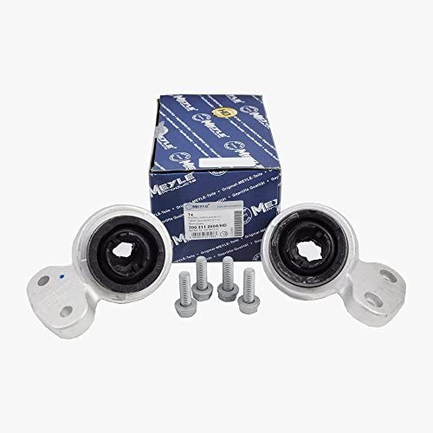

Or,

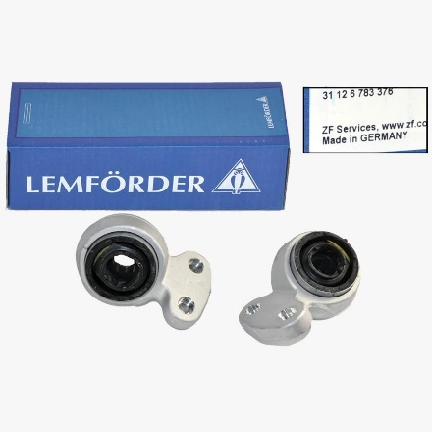

**Install tips:**

If you're replacing just the bushings, you'll need a gear puller to separate the bushing and bracket from the end of the control arm. To reinstall, lube up the control arm and bushing with 1 part soap to 20 parts water and firmly tap onto the arm with a rubber mallet. The end of the control arm should be flush with the end of the bushing. Don't tap on too far and don't tap on too little. When you reinstall the reinforcement plate, make sure you purchase 8 new bolts. These are designed to be changed every time you reinstall the plate. They shear in the event of a crash. You don't want to compromise these very crucial items.

Reinforcement plate bolts: Part number [Link to buy all 8 bolts](http://www.amazon.com/BMW-Genuine-Silencer-Hexagon-M10X35-10-9Zns3/dp/B00JH2D6TO/ref=as_li_bk_tl/?tag=httpvgphotobl-20&linkId=3769b21ef919cc2cf0b696a8d9bdaa89&linkCode=ktl)

Resources:

<http://www.understeer.com/lcab.shtml>